


Present and display food products
D1.HCC.CL2.19
Trainee Manual


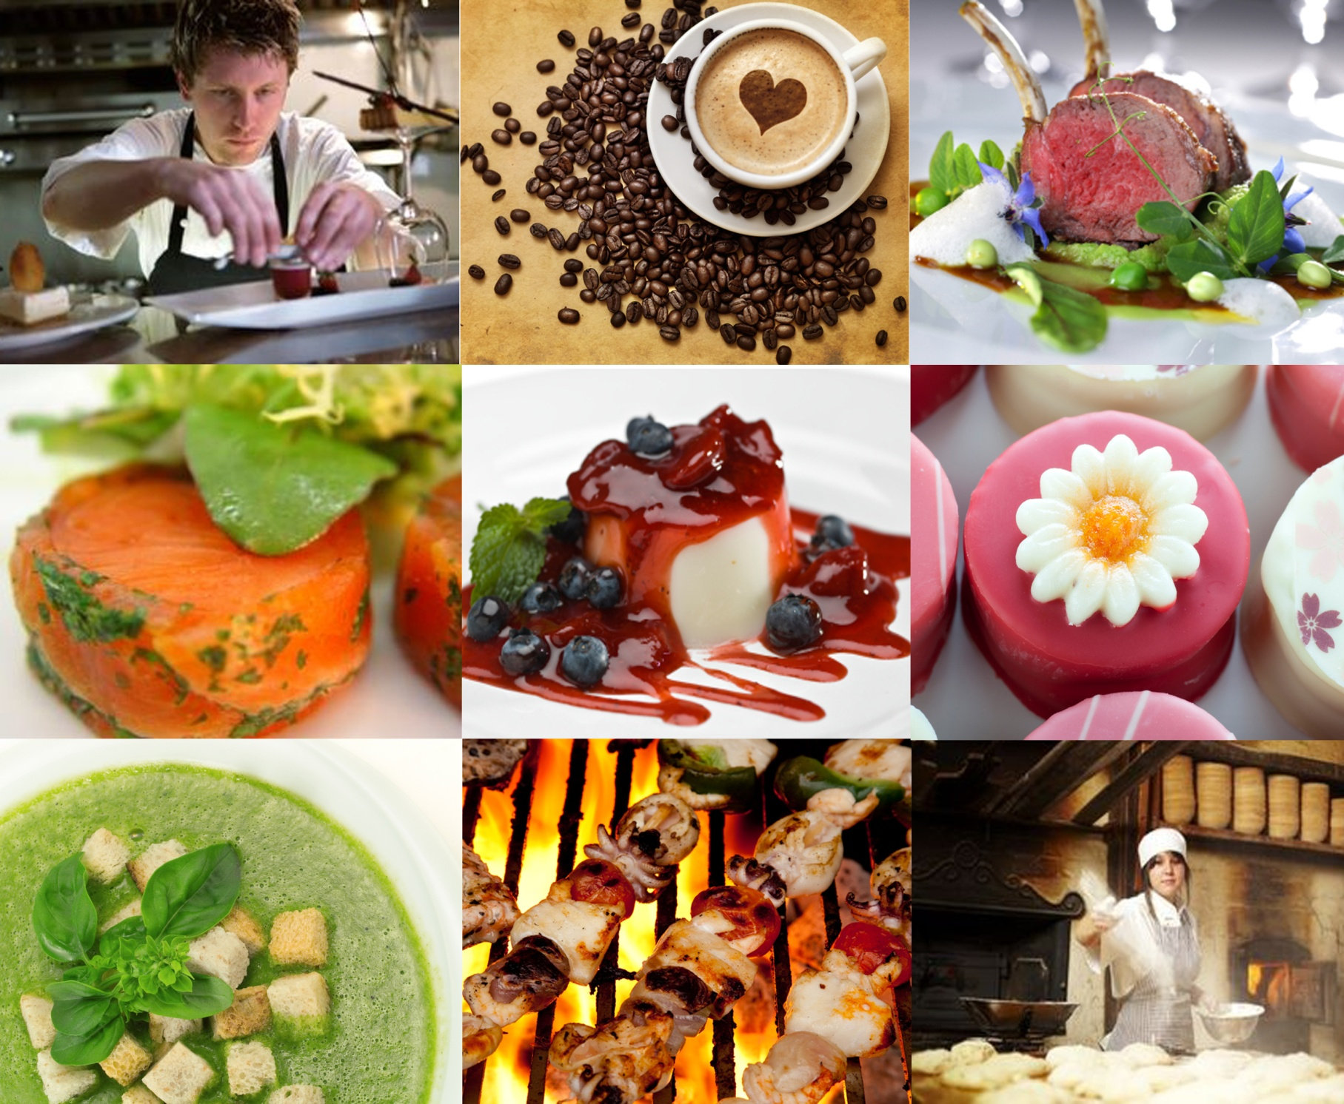



Present and display food products

D1.HCC.CL2.19

Trainee Manual





Project Base
William Angliss Institute of TAFE
555 La Trobe Street
Melbourne 3000 Victoria
Telephone: | (03) 9606 2111
Facsimile: | (03) 9670 1330
Acknowledgements
Project Director: | Wayne Crosbie
Chief Writer: | Alan Hickman
Subject Writer: | Brad Harris
Project Manager: | Alan Maguire
Editor: | Alan Maguire
DTP/Production: | Daniel Chee, Mai Vu, Kaly Quach
The Association of Southeast Asian Nations (ASEAN) was established on 8 August 1967. The Member States of the Association are Brunei Darussalam, Cambodia, Indonesia, Lao PDR, Malaysia, Myanmar, Philippines, Singapore, Thailand and Viet Nam.
The ASEAN Secretariat is based in Jakarta, Indonesia.
General Information on ASEAN appears online at the ASEAN Website: www.asean.org.
All text is produced by William Angliss Institute of TAFE for the ASEAN Project on “Toolbox Development for Front Office, Food and Beverage Services and Food Production Divisions”.
This publication is supported by the Australian Government’s aid program through the ASEAN-Australia Development Cooperation Program Phase II (AADCP II).
Copyright: Association of Southeast Asian Nations (ASEAN) 2013.
All rights reserved.
Disclaimer
Every effort has been made to ensure that this publication is free from errors or omissions. However, you should conduct your own enquiries and seek professional advice before relying on any fact, statement or matter contained in this book. The ASEAN Secretariat and William Angliss Institute of TAFE are not responsible for any injury, loss or damage as a result of material included or omitted from this course. Information in this module is current at the time of publication. Time of publication is indicated in the date stamp at the bottom of each page.
Some images appearing in this resource have been purchased from stock photography suppliers Shutterstock and iStockphoto and other third party copyright owners and as such are non-transferable and non-exclusive. Clip arts, font images and illustrations used are from the Microsoft Office Clip Art and Media Library. Some images have been provided by and are the property of William Angliss Institute.
Additional images have been sourced from Flickr and SKC and are used under Creative Commons licence: http://creativecommons.org/licenses/by/2.0/deed.en
File name: TM_Present_&_display_food_products _FN_240114





Table of contents
Introduction to trainee manual 1
Unit descriptor 3
Assessment matrix 5
Glossary 7
Element 1: Prepare garnishes and accompaniments 11
Element 2: Plate and present foods 33
Element 3: Store garnishes and accompaniments 53
Presentation of written work 65
Recommended reading 67
Trainee evaluation sheet 69
Trainee Self-Assessment Checklist 71

Introduction to trainee manual

To the Trainee
Congratulations on joining this course. This Trainee Manual is one part of a ‘toolbox’ which is a resource provided to trainees, trainers and assessors to help you become competent in various areas of your work.
The ‘toolbox’ consists of three elements:
- A Trainee Manual for you to read and study at home or in class
- A Trainer Guide with Power Point slides to help your Trainer explain the content of the training material and provide class activities to help with practice
- An Assessment Manual which provides your Assessor with oral and written questions and other assessment tasks to establish whether or not you have achieved competency.
The first thing you may notice is that this training program and the information you find in the Trainee Manual seems different to the textbooks you have used previously. This is because the method of instruction and examination is different. The method used is called Competency based training (CBT) and Competency based assessment (CBA). CBT and CBA is the training and assessment system chosen by ASEAN (Association of South-East Asian Nations) to train people to work in the tourism and hospitality industry throughout all the ASEAN member states.
What is the CBT and CBA system and why has it been adopted by ASEAN?
CBT is a way of training that concentrates on what a worker can do or is required to do at work. The aim is of the training is to enable trainees to perform tasks and duties at a standard expected by employers. CBT seeks to develop the skills, knowledge and attitudes (or recognise the ones the trainee already possesses) to achieve the required competency standard. ASEAN has adopted the CBT/CBA training system as it is able to produce the type of worker that industry is looking for and this therefore increases trainees chances of obtaining employment.
CBA involves collecting evidence and making a judgement of the extent to which a worker can perform his/her duties at the required competency standard. Where a trainee can already demonstrate a degree of competency, either due to prior training or work experience, a process of ‘Recognition of Prior Learning’ (RPL) is available to trainees to recognise this. Please speak to your trainer about RPL if you think this applies to you.
What is a competency standard?
Competency standards are descriptions of the skills and knowledge required to perform a task or activity at the level of a required standard.
242 competency standards for the tourism and hospitality industries throughout the ASEAN region have been developed to cover all the knowledge, skills and attitudes required to work in the following occupational areas:
- Housekeeping
- Food Production
- Food and Beverage Service
- Front Office
- Travel Agencies
- Tour Operations.
All of these competency standards are available for you to look at. In fact you will find a summary of each one at the beginning of each Trainee Manual under the heading ‘Unit Descriptor’. The unit descriptor describes the content of the unit you will be studying in the Trainee Manual and provides a table of contents which are divided up into ‘Elements’ and ‘Performance Criteria”. An element is a description of one aspect of what has to be achieved in the workplace. The ‘Performance Criteria’ below each element details the level of performance that needs to be demonstrated to be declared competent.
There are other components of the competency standard:
- Unit Title: statement about what is to be done in the workplace
- Unit Number: unique number identifying the particular competency
- Nominal hours: number of classroom or practical hours usually needed to complete the competency. We call them ‘nominal’ hours because they can vary e.g. sometimes it will take an individual less time to complete a unit of competency because he/she has prior knowledge or work experience in that area.
The final heading you will see before you start reading the Trainee Manual is the ‘Assessment Matrix’. Competency based assessment requires trainees to be assessed in at least 2 – 3 different ways, one of which must be practical. This section outlines three ways assessment can be carried out and includes work projects, written questions and oral questions. The matrix is designed to show you which performance criteria will be assessed and how they will be assessed. Your trainer and/or assessor may also use other assessment methods including ‘Observation Checklist’ and ‘Third Party Statement’. An observation checklist is a way of recording how you perform at work and a third party statement is a statement by a supervisor or employer about the degree of competence they believe you have achieved. This can be based on observing your workplace performance, inspecting your work or gaining feedback from fellow workers.
Your trainer and/or assessor may use other methods to assess you such as:
- Journals
- Oral presentations
- Role plays
- Log books
- Group projects
- Practical demonstrations.
Remember your trainer is there to help you succeed and become competent. Please feel free to ask him or her for more explanation of what you have just read and of what is expected from you and best wishes for your future studies and future career in tourism and hospitality.

Unit descriptor
Present and display food products
This unit deals with the skills and knowledge required to Present and display food products in a range of settings within the hotel and travel industries workplace context.
Unit Code:
D1.HCC.CL2.19
Nominal Hours:
30 hours

Element 1: Prepare garnishes and accompaniments
Performance Criteria
1.1 Identify menu items that require garnishes and/or accompaniments
1.2 Prepare various garnish and/or accompaniments
1.3 Set up for service

Element 2: Plate and present foods
Performance Criteria
2.1 Portion food items to enterprise standards
2.2 Provide sufficient and appropriate service equipment and service platforms
2.3 Plate and display food items to menu style
2.4 Present food neatly and attractively

Element 3: Store garnishes and accompaniments
Performance Criteria
3.1 Store items correctly
3.2 Store products appropriately in correct containers
3.3 Label products correctly
3.4 Store items in correct conditions to maintain freshness and quality

Assessment matrix
Showing mapping of Performance Criteria against Work Projects, Written Questions and Oral Questions
The Assessment Matrix indicates three of the most common assessment activities your Assessor may use to assess your understanding of the content of this manual and your performance – Work Projects, Written Questions and Oral Questions. It also indicates where you can find the subject content related to these assessment activities in the Trainee Manual (i.e. under which element or performance criteria). As explained in the Introduction, however, the assessors are free to choose which assessment activities are most suitable to best capture evidence of competency as they deem appropriate for individual students.
 |  |  | Work Projects | Written Questions | Oral Questions
Element 1: Prepare garnishes and accompaniments
1.1 | Identify menu items that require garnishes and/or accompaniments |  | 1.1 | 1, 2, 3 | 1, 2
1.2 | Prepare various garnish and/or accompaniments |  | 1.2 | 4, 5, 6, 7 | 3,4
1.3 | Set up for service |  | 1.3 | 8, 9,10 | 5
Element 2: Plate and present foods
2.1 |  | Portion food items to enterprise standards | 2.1 | 11,12,13 | 6
2.2 |  | Provide sufficient and appropriate service equipment and service platforms | 2.2 | 14,15,16 | 7
2.3 |  | Plate and display food items to menu style | 2.3 | 17 | 8
2.4 |  | Present food neatly and attractively | 2.4 | 18,19 | 9
Element 3: Store garnishes and accompaniments20
3.1 | Store items correctly |  | 3.1 | 20 | 10
3.2 | Store products appropriately in correct containers |  | 3.2 | 21 | 11
3.3 | Label products correctly |  | 3.3 | 22 | 12
3.4 | Store items in correct conditions to maintain freshness and quality |  | 3.4 | 23, 24 | 13

Glossary
Term | Explanation
Accompaniment | Food item served to compliment the flavour or to add texture to another menu item
Amuse bouche | A high quality appetiser usually designed to demonstrate the expertise of the Chef
A la carte | Service style where customers select from an extensive menu and food is cooked to order
Appetiser | First course of an à la carte or banquet menu
Bain-marie | Water bath used for hot holding of food
Back up | Additional, prepared food items kept in storage during service periods
Banquet | Service style where guests are seated and served at the same time
Buffet | Service style where guests select or self-serve from displayed menu items
Chafing dish | Portable unit for hot food display on a buffet
Condiment | An accompaniment such as a sauce served separate to a menu item
Cuisine | Style of food that may relate to a particular country or culture
Component | A food item which makes up the overall presentation of a dish
Classical | Standard menu item that has not changed over time
Cryovac | A method of vacuum packaging food items for storage or cooking
Entree | Second course on an à la carte or banquet menu
Filigree | Piped chocolate figures or shapes
Fleuron | Small puff pastry garnish for soups
Food grade | Made from a product which will not contaminate food
Garnish | An edible decoration used to enhance the overall presentation of a menu item
Gratinate | To brown and crisp a food item under a grill
Glaze | A reduced liquid used to add final shine to a menu item
Humidity | Excessive moisture in air
Hot box | Storage vehicle for hot food items. Usually used in banqueting or buffet style service
Julienne | A uniform matchstick sized cut of vegetable
Ladle | Portion control service item for soups and other wet dishes
Nappe | To neatly coat a food item with a sauce
Osmosis | Transference of water into plant cells which assists in crisping
Prop | A display item used to enhance the overall appearance of a buffet table
Platter | A flat round, oval or square service platform used to serve large portions
Portion | Quantity of food allocated to a menu item either by weight or volume
Ramekin | Small round ceramic dish used for presenting items such as soufflé or crème brulee
Sambal | An accompaniment such as sauce or condiment served with Indian dishes
Salsa | A chunky vegetable sauce served with Spanish and Southern Americas cuisines
Service | A period of time during which meals are cooked and served to customers
Service platform | A vessel or flat item of equipment used for plating, display and presentation of food items
Sippet | Small bread crouton served as an accompaniment to soups
Station | Section of the kitchen or dining area where food is cooked, displayed or served
Savoury | Having a salt or earthy flavour
Section | An area of a kitchen allocated to specific components of service or production of particular menu items
Sprig | A small picked section of a herb plant used as a plate garnish
Spatula | A flat serving item used for lifting and plating delicate foods
Salver | A highly polished round or oval silver platter
Texture | Relates to the feel of food in the mouth as it is eaten
Tureen | A service vessel for hot wet dishes such as soups or stews
Table d hote | Style of service similar to banqueting. Normally a set menu.
Uniform | Even in shape, size, colour and texture
Wasabi | A pungent, spicy radish paste used as an accompaniment to Japanese cuisine
Yield | The amount of food product produced from a standard recipe

Element 1:
Prepare garnishes and accompaniments

1.1 Identify menu items that require garnishes and/or accompaniments

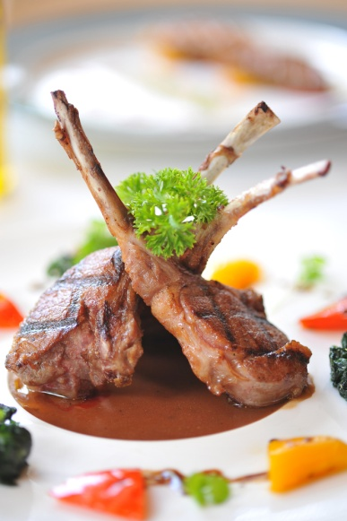
Introduction
Good food presentation is an important consideration for any quality food business, whether they are a café, restaurant or large scale catering operation.
Quality of food presentation is always a critical aspect of the customer’s dining experience and satisfaction.
Food must be made to look as attractive as possible, without detracting from the main ingredient. Correct presentation techniques allow the food to be displayed to its best potential.
Modern food presentation relies on quality ingredients and tends to focus on healthy eating habits. Clean and simple plating of food is more common these days.
Although good presentation is important, the flavour, seasoning and quality of ingredients must be considered, as a customer can quickly become disappointed if the meal looks attractive but lacks flavour or has poor texture.
Identifying appropriate garnishes for different foods
Most menu items will require some form of garnishing to enhance their presentation and this is, in fact, an expectation of customers.
Many customers are familiar with the type of food that they are ordering and come to expect certain accompaniments and their food to have a familiar appearance or texture, especially if it is a classical dish or a particular type of cuisine.
The best way to identify appropriate food garnishes is to study the menu and recipe requirements.
A menu will often describe the type of garnish required for each item. Some garnishes are not described on the menu or in the recipe but are simply placed, at the Chef’s discretion, as a decoration to enhance the presentation of the dish.
Some common garnishes that may not necessarily be identified on the menu include:
- Lemon wedges for fish dishes
- Chopped or picked herbs for most savoury dishes
- Fruit, such as strawberries for garnishing desserts.
When selecting garnishes for menu items, you should always consider the compatibility with the main component of the dish. This is because many food items do not taste good or look attractive together.
For example, you would not serve lemon or citrus items with beef as the flavours do not complement each other.
Certain herbs compliment particular types of meat fish and poultry, others will not.
You would not usually use the herb ‘Rosemary’ as a garnish for pork or seafood. In European cooking, this herb is normally used to compliment lamb dishes.
Sweet accompaniments, such as biscuits or fruit would not usually be presented with savoury menu items.
Menu item | Garnish herbs or spices
Fish | Dill, parsley, chives, cilantro (coriander), spring onion
Beef | Parsley, chervil, thyme, oregano
Lamb | Rosemary, mint, parsley, chervil
Pork | Tarragon, thyme, dill, parsley
Chicken | Tarragon, basil, fennel
Duck | Parsley, chive, chervil
Eggs | Chives, parsley, chervil
Desserts | Mint leaves, berries, cinnamon
Soups and stews | Parsley, chervil, chives, cilantro, thyme
Cakes and pastries | Mint leaves, berries, cinnamon, nutmeg
For some menu items, the garnish may be described on the menu. This is usually done to make the dish sound more interesting and appealing to the customer.
Some examples of garnish descriptions on the menu include:
- Steamed fish garnished with julienne of root vegetables (garnish)
- Cream of carrot soup served with garlic croutons
- Mushroom risotto topped with shaved Pecorino cheese (garnish)
- Chocolate Panna Cotta served with pistachio tuille biscuit (garnish).
In the examples given above, the garnish has been included in the description of the menu item.

Cuisines
‘Cuisine’ refers to the particular type of food that is offered by a business.
A cuisine usually relates to a particular country or region of a country where the type and style of food has developed over a long period of time.
Cuisines mostly developed around what local produce was available and the different methods of preserving, flavouring and cooking locally sourced food items.
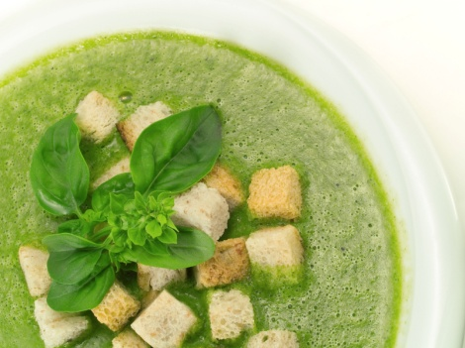
Examples of how cuisines may have developed:
- Types of local industry – fishing, animal farming
- Types of local produce – vegetables, herbs and spices
- Traditional methods of preserving food – pickling, salting, smoking
- Traditional methods of cooking food – hibachi grill, tandoor oven, wok.
As an example, a seafood based cuisine could develop from the coastal region of a country where fishing is common and where seafood is abundant. Seafood may develop as the main theme or cuisine of the area.
Different cuisines also usually have unique, traditional styles of presentation such as wrapping food in leaves or serving food in a particular vessel.
Some Asian cuisines have particular ceremonial practices that are observed as an important part of tradition.

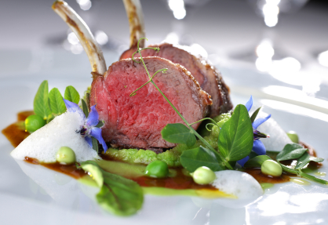
Menu Items
Menu items are dishes or components of dishes that are prepared and served to customers.
Components of menu items include:
- Main protein – meat, seafood, poultry
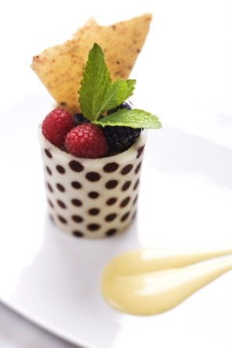
- Protein alternatives – soy products, high protein vegetables and legumes
- Starches – rice, pasta, grains or cereals
- Vegetables and fruits – to balance nutrition and make the entire menu item more interesting
- Desserts, cakes and pastries
- Sauces and dressings – to enhance the flavour of the menu item
- Garnishes – edible food items used to make the dish look more attractive
- Accompaniments – to compliment the flavour or to add texture to a menu item.
A menu item may contain all or only some of these components, depending on the style of food and the cuisine being offered.

1.2 Prepare various garnish and/or accompaniments
Garnishes
A garnish refers to a food item that is used to enhance the overall presentation of the menu item. This means adding colour and texture to the menu item, making the dish more visually appealing to the customer.
Plate garnishes should be fresh, may be edible and must compliment the menu item being prepared.
Examples of food garnishes include:
Garnish ingredient | Examples
Fresh herbs | Parsley, chives, chervil, cilantro, dill, basil, mint
Woody herbs | Fried sage, thyme, rosemary (these are bitter and require cooking)
Edible flowers | Nasturtium, dandelion, zucchini, caper
Edible leaves | Lettuce, spinach, endive, roquette
Shoots and sprouts | Pea shoots, bean shoots, lotus root
Vegetables – raw or cooked | Cuts including julienne, brunoise, paysanne, jardinière, noisettes  Fried shallots, roasted garlic
Fruits | Segmented citrus, diced, dried, candied
Pastry – short or puff | Fleurons, cases, toppings
Bread | Croutons, sippets
Eggs | Omelette, royale, whole poached or fried
Nuts – whole, toasted, crushed | Coconut, peanuts, walnuts, hazel nuts, almonds
Edible seeds | Poppy, sesame, pumpkin
Spices | Paprika, cinnamon, nutmeg, cracked pepper
Chocolate | Shaved, piped filigree, baskets, powder/cocoa
Sugar | Pulled, candy, toffee, praline
Biscuits | Tuille, shortbreads, macaroons

Garnishes may range from very simply prepared food items to quite elaborate and time consuming artistic creations.
Garnishes may be required for presentation on a plate or for display on a buffet service.
Some important things for you to consider when planning and designing the presentation of menu items include:
- The menu item, style and cuisine
- The service style – à la carte, banquet, buffet
- The service period – breakfast, lunch, dinner, cocktail party
- The cost and selling price of the menu item
- Time constraints
- Availability of products used for garnishes
- The cost of garnish items
- Equipment required for preparing garnish items
- The skills and ability of the person preparing the garnish or accompaniment items.
Accompaniments
An accompaniment is used to add to texture and taste to a menu item. Accompaniments should be appropriate and compliment the main food item.
Accompaniment | Examples
Glazes | Hot or cold. Reduced stock or aspic jelly to give food a shiny appearance
Sauces | Hot or cold, sweet or savoury. To add colour, flavour and texture to food
Vegetables | Cut into neat uniform shapes or styles such as julienne or paysanne. These may be cooked, dried, raw or pickled
Fruits | Lemon wedges, orange segments, dried apricots, candied mango
Biscuits | Tuille, macaroons and meringues for desserts
Condiments | Dipping sauces and pastes such as soy sauce, wasabi, pesto and salsa
Cheeses | Grated or shaved or formed into baskets or used for gratinating
Dairy foods | Whipped cream, sour cream, yoghurt for desserts or to compliment spicy dishes
Bread | Croutons, sippets

Many accompaniments are traditional to certain styles of cuisine and you must consider this when planning the presentation of menu items.
Examples of cuisines and traditional accompaniments:
Cuisine type | Common accompaniments
Japanese | Soy sauce, pickled ginger and wasabi
Italian | Parmesan cheese, vegetable and herb pesto
Indian | Sambals, naan breads, dhal
Mexico | Salsa, guacamole, tortilla, sour cream
Cantonese | Shrimp paste, char siu sauce
Vietnamese | Nuoc Mam, green banana, bean sprouts
When developing menu items it is important to consider the suitability of garnishes and accompaniments.
You must always ensure that the flavours, textures and colours of these items will appropriately enhance the overall item and that the cuisine style has been considered.

Alternative garnishes and accompaniments
Some customers may have allergies or suffer medical reactions by eating certain foods.
Common allergy foods include:
- Wheat flour – gluten
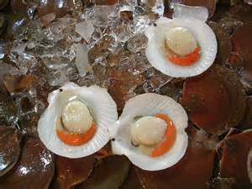
- Shellfish
- Nuts
- Pollen – honey
- Dairy foods – such as milk and cream.
Common dietary conditions include:
- Diabetes – excluding fats and sugars
- Obesity – requiring low sugar and fat content
- High cholesterol – requiring low fat content
- High blood pressure – requiring low salt content.
Other customers may have traditional, religious or other beliefs that prevent them from eating certain foods.
Examples:
- Vegans – eat no animal products at all
- Muslims – eat no pork or pork products
- Hindus – eat no beef or beef products.
You must always consider these issues as your customers may become ill or highly offended.
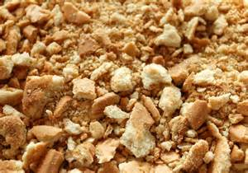
Some ways to substitute foods:
- Wheat flour for corn flour
- Crushed biscuits for nuts
- Soy products for dairy products
- Honey for sugar
- Yoghurt for cream.
There are food suppliers available who stock a range of products to meet certain religious or philosophical dietary needs.
Click on the link to view the website below. This will give you some great ideas and inspiration on food presentation techniques for buffets.
http://www.howtogarnish.com/

Preparing garnishes and accompaniments
Some food items can be categorised as a garnish, accompaniment or both, depending on how they are presented.
An item that is served in or on a plated menu item would be referred to as a ‘garnish’.
Food items that are served or presented separately or alongside a menu item would be considered as an ‘accompaniment’.
Need for artistic skill
Like with all aspects of food service, artistic skill is essential to ensure that plates are served in an appealing manner.

Standard recipes
A standard recipe is one which is used over and over again in a business.
Using a standard recipe means that, if followed correctly, the menu item will turn out to the same standard each time it is prepared, regardless of who prepares it. This is important in meeting the expectations of customers.
Following a recipe correctly requires good organisational skills. This ensures that;
- All ingredients are available and correctly measured
- All required equipment is available and at hand
- The menu item will look and taste the same each time it is prepared.

A standard recipe will often describe what garnishes and accompaniments are used to compliment the menu item.
Elements of a standard recipe
Name of the menu item  MENU  Battered flat head tails with hand cut chips | What is the name of the dish or menu item?  This usually describes what the item is. It may be a basic preparation used in other dishes or the dish itself.  Most recipe names are simple and self-describing e.g. Chocolate mud cake.  Some recipe names may only describe the main ingredient and also have a classical term e.g. Veal Parmagiana.
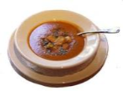      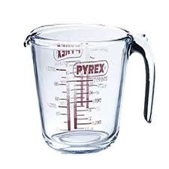  Portion and yield | How much or how many serves will this recipe produce?  ‘Yield’ relates to the overall amount produced by the recipe.  ‘Portion’ relates to ‘how many’ individual serves can be made from the yield.  Recipe yield = 1000g  Portion size = 100g  Portions produced = 10
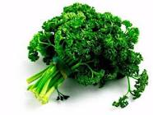  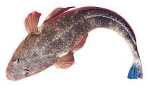  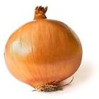  Ingredients | What food items are to be used?  Some recipes call for specific types of ingredients. For example, the recipe may state either white or black pepper.  When using a recipe, it is important to use specified ingredients as the taste or look of the finished item may not be what was expected.  Some items can be substituted but usually, only experienced cooks know how to properly substitute ingredients.  Quality is another important issue in selecting ingredients. A particular standard such as ‘ripe tomatoes’ or ‘fresh garlic’ may be needed for the overall quality standard of a dish to be achieved.
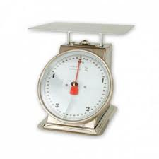  Quantities | How much of each ingredient is to be used?  It is important that ingredients are correctly weighed or measured. Incorrect quantities can ruin the overall taste, texture or look of the finished item.  Quantities are commonly shown in modern recipes using the metric system.
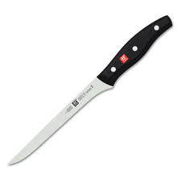  Equipment | What do we need to prepare process, cook and store the ingredients?  This may include cooking vessels, hand tools, large equipment, knives and specialised equipment.  It is important to select the correct piece of equipment for the job. For example; a 10 litre pot is not suited to making 2 litres of soup.
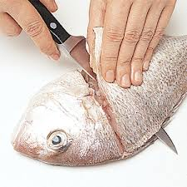  Method of preparation | How do we go about preparing, processing and cooking the ingredients?  This is always done in logical steps and may include:  Pre-heating equipment  Cutting or chopping  Mixing, blending, processing  Special techniques such as kneading, marinating or trussing  Methods of cooking (i.e. Boiling, grilling, baking)  Cooling  Storage.
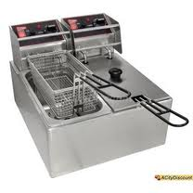  Methods of cookery | How do we apply heat to the food item?  Using different methods of cookery affects the final taste, colour and texture of the food item being cooked.  Not all food items can be subjected to each cookery method.  For example, tough cuts of meat require long slow cooking methods like stewing; tender cuts of meat require fast methods such as grilling or frying.  A recipe will describe what cookery method should be used. The common cookery methods are classed as ‘wet’ or ‘dry’.  Wet methods include; boiling, poaching, simmering, steaming and stewing.  Dry methods include; roasting, grilling, sauté, baking, deep frying.
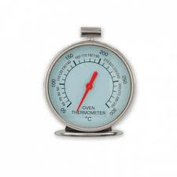  Cooking temperatures | How hot or cold does the cooking vessel need to be?  Temperatures are commonly shown in modern recipes using the metric system and displayed as °C or degrees Celsius.  Example; ‘Preheat oven to 180°C’.  Using the correct temperature is important as the food item may end up overcooked/burnt or undercooked/raw.
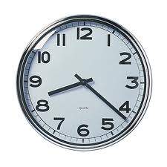  Cooking times | How long must we allow the food item to be subject to heating or cooling?  This is important as different foods may require longer or shorter cooking times.  If food is undercooked it may be tough or unsafe to eat.  If food is overcooked it may have broken down to become too soft or it may be dry or, even worse, burnt.  If foods are not cooled to the correct temperature this may ruin the next step in the cooking or preparation process.  Pre-heating is a process of bringing an oven, grill or pan to temperature so that the food item can begin to cook immediately.
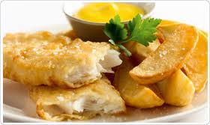  Presentation | How do we display the food item to the customer?  Presentation is of high importance as it is the first impression that is given to the customer.  A recipe will usually describe:  The portion size  The serving vessel (dish, bowl, plate)  The garnish (decoration, sauce)  Any accompaniments to compliment the dish  The layout of the dish components on the plate  The recommended serving temperature.
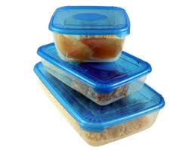  Storage | Modern recipes will often give storage tips or guides.  Storage may be cold, frozen, hot or ambient (room) temperatures.  Correct storage is important for 2 reasons:  Quality – foods may dry out or be exposed to insects, dust and other forms of contamination  Food safety – foods may become cross-contaminated or develop dangerous levels of bacterial growth  Some recipes are cooked to order and do not require storage instructions.

Preparing garnishes
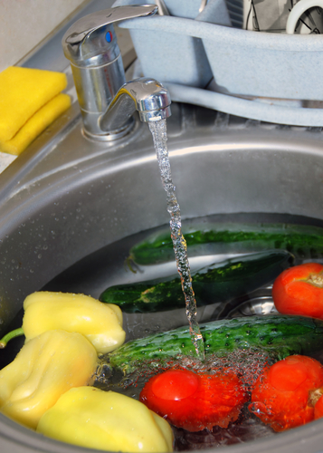
As garnishes are designed to add eye appeal to menu items, you must consider the following points when preparing them:
- Select fresh looking herbs, leafy greens, fruits or vegetables
- Thoroughly wash any herbs, fruits or vegetables that are to be used
- Remove any leaves that are dead, withered
- Beware of items that may have been chewed by insects or show signs of insect activity
- Pick herb sprigs of appropriate size so as not to overwhelm the main ingredient
- Peel and trim fruits and vegetables neatly and remove any pips
- Cut fruits and vegetables evenly and uniform in shape and size
- Ensure that the garnish is edible – some fruits, berries, plants and leaves can be bitter or poisonous.
Some garnishes require preparation following a recipe. These may include items such as biscuits or pastry.
These items must also be of good quality and appearance so therefore you must follow the recipe precisely:
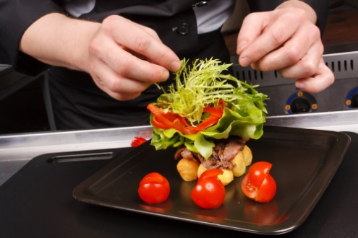
- You must also consider the storage requirements of prepared garnishes as they may lose texture by becoming soft, brittle or stale
- Herbs, fruits and vegetables can become withered or dried out and chopped herbs and leaves can ‘compost’ making them odorous and inedible.
- Low quality, poorly prepared or inappropriate garnishes will make menu items appear less attractive and can even lead to customer complaints.
Equipment for preparing garnishes
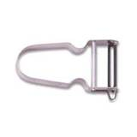 | 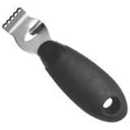 | 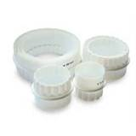
Peeler | Zester/channel cutter | Pastry cutters
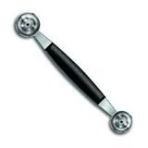 | 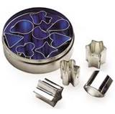 | 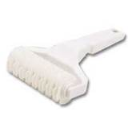
Parisienne/Noisette cutter | Shape cutters | Pastry trellis cutter

Preparing accompaniments
Accompaniments are usually traditional items that may have some cultural significance or may simply have developed as a common, complimentary ‘partner’ to some foods.
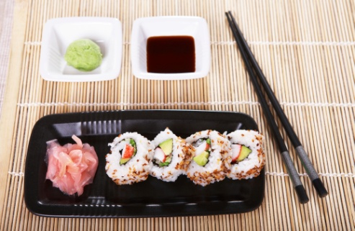
Many accompaniments can be purchased pre-prepared. These include items such as:
- Soy sauce
- Wasabi
- Mustard
- Ketchup
- Mayonnaise.
Others may be partially prepared and only require some basic preparation, heating or cooking.
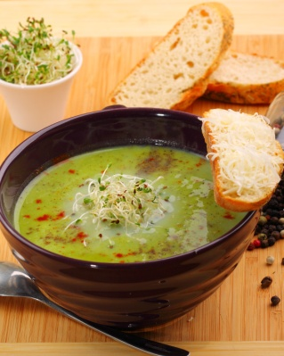
These include items such as:
- Fried shallots
- Toasted nuts
- Chopped chillies
- Sambals
- Salsas
- Citrus fruits
- Specialty breads
- Chocolate and sugar decorations.
Accompaniments that require preparation should be made as close to serving time as possible so as to retain freshness and colour.
Dressings and sauces may be made in advance to allow the combination of flavours to develop.
As with garnishes, food items used for preparing accompaniments must be fresh and of good quality.
Common Asian meal accompaniments include sauces, pastes and preserved foods items such as:
- Soy sauce
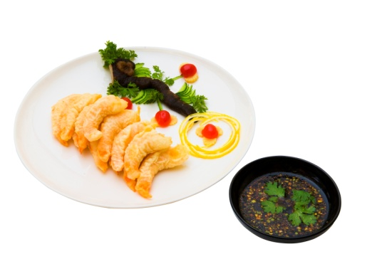
- Wasabi paste
- Dried chillies
- Pickled ginger
- Fish sauce
- Shrimp paste
- Black bean sauce
- Sambals
- Toasted nuts
- Chapatti
- Fried eggs and noodles.
Common European or ‘Western’ food accompaniments include:
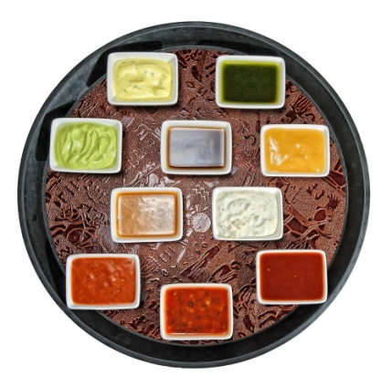
- Mustard
- Mayonnaise
- Ketchup
- Mint sauce or jelly
- Cranberry sauce
- Breads
- Compound butters
- Lemon juice or wedges
- Vinegars.
Traditional European ‘Western’ accompaniments for particular meats include:
- Roast beef – horseradish or mustard, Yorkshire pudding
- Roast pork – Apple sauce, pork crackling (salted skin)
- Roast lamb – Mint sauce or jelly
- Roast turkey – cranberry sauce, yams
- Fish – lemon wedges, tartare sauce, chips
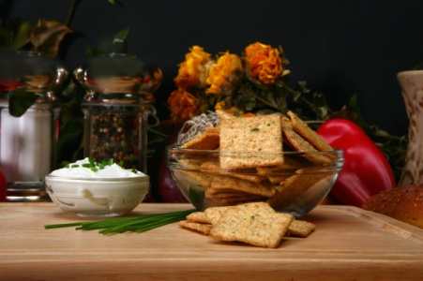
- Shellfish – lemon wedges, cocktail sauce
- Pasta – parmesan cheese.
Other accompaniments can include flavoured or unflavoured dairy items such as:
- Sour cream
- Soft cheeses
- Yoghurt.
When preparing and serving menu items you must always consider the type of cuisine being served and ensure that any accompanying food items are appropriate to the style of food that is to be presented.

1.3 Set up for service

Introduction
The term ‘Service’ relates to the period of time in which customers will select, order and consume their meals.
Set up procedures will depend upon the type of menu and service style of the business.
If the kitchen and dining service areas are correctly laid out and ‘mise en place’ has been properly carried out, the kitchen should function smoothly during the service period.
Poor preparation for service can lead to mistakes being made in the plating and presentation of menu items.
Some good practices to follow to help ensure that service is carried out smoothly include:
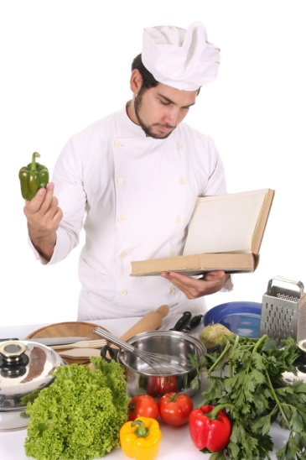
- Study any recipe cards if available to familiarise yourself with menu items and their components
- Have checklists to follow during preparation and leading up to service periods
- Report any problems, such as lack of ingredients or service items as soon as you notice them
- Participate in kitchen briefings prior to service to ensure that you understand the sequence of service and how menu items are to be portioned, plated and garnished.

Setting up for food service
Calculating quantities of food required for the service period
This is an important aspect of service for any catering establishment or food business. Having too little food prepared can mean running out of menu items, leading to customer dissatisfaction and complaints.
Too much food prepared can lead to wastage and high food costs.
Quantities of food required for service can be determined in a number of ways including:

- Reviewing guest bookings
- Reviewing historical sales data
- Historical popularity of certain menu items
- Observing current trends in food and cuisine styles
- Seasonal availability of food products.

Setting up stations for food service
A ‘station’ is a section of the kitchen which may service a particular menu course or specific food items.
A section will require the following items to be available and at hand and in quantities to meet the need of the particular service period and expected number of diners:
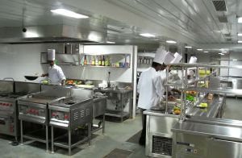
- Cooking vessels such as pots and pans
- Serving equipment such as tongs, spatulas, ladles, trays
- Serving platforms including plates, bowl, trays and platters
- Prepared food items such as steaks, fish, poultry, vegetables
- Accompaniments and garnishes.
Additionally, heating and cooking equipment, such as grills, salamanders and ovens and deep fryers and bains-marie must be at operating temperature.
The term ‘station’ may also refer to sections of a buffet where particular food items are presented and displayed including:
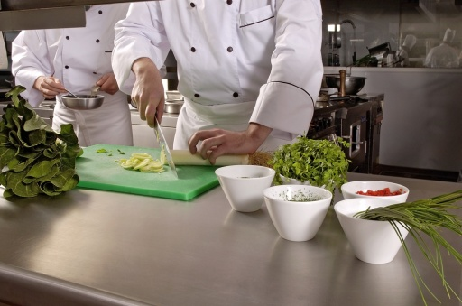
- Soups
- Appetisers and entrees
- Salads
- Carvery for roast meats
- Main course wet or dry dishes
- Vegetable dishes
- Desserts including pastries and cakes.

Equipment required for service periods
Items used for banqueting service:
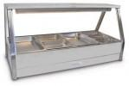  Bain-marie | 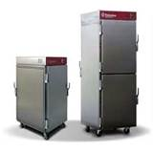  Hot boxes (food warmers)
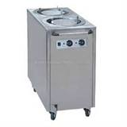  Plate warming unit | 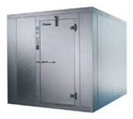  Coolroom unit

Items used for buffet presentation and service:
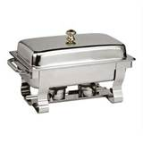  Chafing dish rectangular | 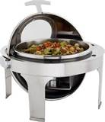  Chafing dish round
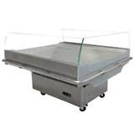  Cold display unit | 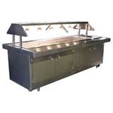  Warm display unit
  Bain-marie | 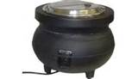  Soup tureen

Holding and storage of foods for service
A la carte service:
For à la carte style service, many foods are portioned into containers and kept refrigerated for use. This practice ensures consistent portioning and minimises waste.
A la carte food service can also rely on the use of a bain-marie to keep certain food items such as vegetables, sauces and soups hot prior to and during the service period.
It is recommended that foods that do not keep well under heat for long periods of time are not stored for service in this manner.
Foods that do not store well in a bain-marie for long periods include items such as:
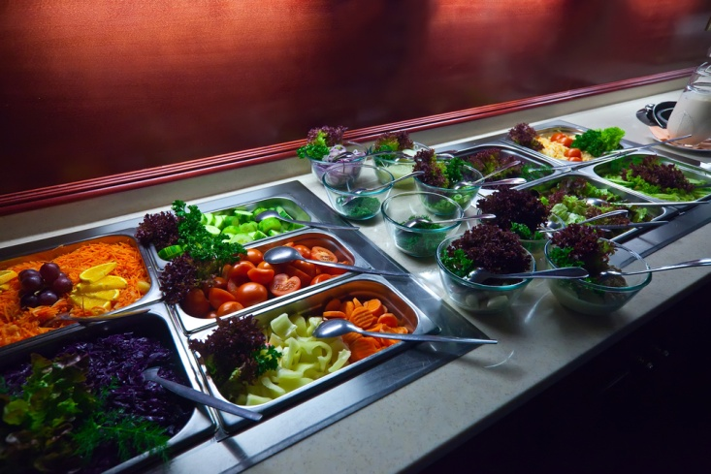
- Leafy vegetables – lose colour and moisture
- Green vegetables – lose bright colour
- Battered or crumbed food items – lose crisp texture and become soft
- Egg based items and butter based sauces – may split lose moisture or water content.
Long term hot storage of these items can ruin presentation in colour and texture, making them visually and texturally unpleasant.
Banqueting and table d'hote service:
These styles of food service mostly rely on the use of bains-marie and hot boxes to keep large quantities of food hot for service. Bains-marie and hot boxes are usually transportable and can be transferred from the kitchen to a particular service area for banqueting or buffet service.
The plating of foods for these styles of service is usually very quick so foods are not kept for long periods of time.

Hot menu items for banqueting may include:
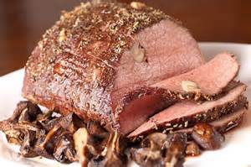
- Roast meats
- Wet dishes (soups, braises and stews)
- Prepared, fabricated meats, poultry and seafood
- Vegetable dishes or accompaniments
- Starches (rice, pasta, potato dishes)
- Sauces
- Garnishes.
Cold items for banqueting are usually stored in a large refrigerated ‘coolroom’ or portable refrigeration units.
Cold items may include:
- Chilled soups
- Cold appetisers and entrees
- Desserts, dessert garnishes and accompaniments
- Other cold garnishes and accompaniments.
Some of these items, such as entrees and desserts may be pre-plated and garnished just prior to service.
This saves time during the service period and also allows for neater, uniform presentation as there is less time pressure, minimising mistakes.
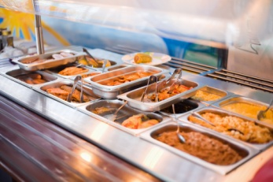
Buffet service
For hot food items, either a bain-marie or ‘chafing dishes’ may be used during buffet service.
Chafing dishes are transportable free standing units that can be filled with water and usually rely on canned fuel (kerosene gel), which is placed under the dish and a flame is lit.
This flame can last for up to 2 hours, heating the water which keeps the menu item warm or hot.
Chafing dishes are traditional to the buffet and actually add to the overall presentation as they are usually made of highly polished silver or stainless steel.
Cold buffet items are usually presented in a refrigerated display unit. Some buffet items may be displayed on ice if refrigeration is unavailable.
Food safety
Regardless of the style of service, food safety must always be considered when holding, storing, plating and presenting food.
Hot food items should be held at a temperature above +65°Celsius and cold food at +5°C or below (the temperature danger zone is 5°C – 60°C).
Foods held within the temperature danger zone for a period of longer than 2 hours can be hazardous to eat and may cause food poisoning.
Clean, sanitised serving utensils and storage or serving vessels should be used.
During busy plating periods it is sometimes not practical to use serving utensils. If hands are to be used for plating of food, sterile food handling gloves should be worn to lower the risk of cross contamination.

Back up food items for service periods
Having back up food items prepared is an important consideration for any service period and is a common aspect of mise en place.
This practice ensures that food items will not run out or that customers will not be waiting for long periods for items to be prepared.
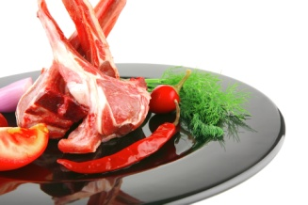
Regardless of good planning, any food business can encounter an unexpectedly busy period and back up food is essential to ensuring customers’ demands are met.
Examples of backing up menu items include:
- Meats such as steaks are cut and portioned
- Processed food items such as crumbed foods are prepared
- Fabricated or prepared meat, poultry and seafood items are available
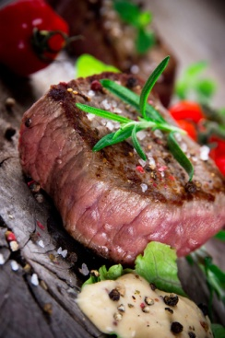
- Extra vegetables and other accompaniments such as rice or pasta are par cooked
- Extra sauces and condiments are prepared or are in stock
- Extra garnishes have been prepared.
It is certainly not easy to gauge how much back up food may be required but always allow for at least an extra 10% of anticipated sales.
On many occasions, guests may bring unreserved companions or guest numbers for functions may increase unexpectedly.
Unused back up items can and should be utilised first during a subsequent service period.
The exception to this is if the prepared food has been reheated or held at an unsafe temperature over an extended period of time. In these circumstances leftover back up food should be discarded.

Work Projects
It is a requirement of this Unit that you complete Work Projects as advised by your Trainer. You must submit documentation, suitable evidence or other relevant proof of completion of the project to your Trainer by the agreed date.
  - Study your work menu and write a list of all garnishes that are used for the various menu items. Present this to your trainer/assessor.
1.2. Obtain a recipe for 2 garnishes and 2 accompaniments used on your work menu. Prepare these items and present them to your trainer/assessor for evaluation.
1.3. Write down the style of service and type of cuisine used in your workplace. Below this, write a list of all equipment used in your workplace for set up and service of menu items. Present this list to your trainer/assessor.

Summary

Prepare garnishes and accompaniments
Identify appropriate garnishes for different foods
Most menu items will require some form of garnishing to enhance their presentation and this is, in fact, an expectation of customers
Most customers are familiar with the type of food that they are ordering and come to expect certain accompaniments, especially if it is a classical dish or a particular type of cuisine
The best way to identify appropriate food garnishes is to study the menu and recipe requirements
A menu will often describe the type of garnish required for each item. Some garnishes are not described on the menu or in the recipe but are simply placed (at the Chef’s discretion) as a decoration to enhance the presentation of the dish.
Prepare various garnishes and/or accompaniments
A garnish refers to a food item that is used to enhance the overall presentation of the menu item:
Plate garnishes should be fresh, edible and must compliment the menu item being prepared
Garnishes may range from very simply prepared food items to quite elaborate and time consuming artistic creations
Garnishes may be required for presentation on a plate or for display on a buffet service
An accompaniment is used to add to the texture and taste to a menu item. Accompaniments should be appropriate and compliment the main food item
Many accompaniments are traditional to certain styles of cuisine and you must consider this when planning the presentation of menu items
You must always ensure that the flavours, textures and colours of garnishes or accompaniments will appropriately enhance the overall item and that the cuisine style has been considered.
Set up for service
Set up procedures will depend upon the type of menu and service style of the business:
Poor preparation for service can lead to mistakes being made in the plating and presentation of menu items
Calculating quantities of food correctly can ensure customer needs are met and wastage/food cost is minimised
Quantities of food required for service can be determined in a number of ways including reviewing guest bookings and reviewing historical sales data
A ‘station’ is a section of the kitchen which may service a particular menu course or specific food items
The term ‘station’ may also refer to sections of a buffet where particular food items are presented and displayed
For à la carte style service, many foods are portioned into containers and kept refrigerated for use. This practice ensures consistent portioning and minimises waste
Banquet service mostly relies on the use of bains-marie and hot boxes to keep large quantities of food hot for plating and service
For buffet service, either a bain-marie or ‘chafing dishes’ may be used for holding of hot foods. Cold foods are kept in a refrigerated display unit
Hot food items should be held at a temperature above +65°Celsius and cold food at +5°C or below
Foods held outside of these temperatures for a period of longer than 2 hours can be hazardous to eat and may cause food poisoning
Having adequate back up food ensures that food items will not run out and that customers will not be waiting for long periods for items to be prepared.

Element 2:
Plate and present foods

2.1 Portion food items to enterprise standards

Introduction
Portioning and portion control are important aspects of food presentation.
Food presented to customers must be consistent in quantity and size and uniform in shape and appearance.
Uneven size and inconsistent presentation reflects back on the kitchen and can portray to customers that the business does not really care about the impression being made.
Portion sizes or quantities should always be in line with business policy or standard recipes.

Portioning
Portioning refers to the amount of food allocated to a particular menu item. This may include several components of a dish or a single serve item.

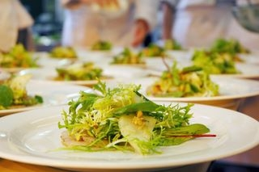
Portion control
Good portion control practices allow the kitchen to control its costs.
When a dish is prepared using a standard recipe the head chef will know how much the ingredients cost and have an expectation of the yield the recipe will produce.
By using the expected profit margin for the kitchen, the selling price for the dish can be calculated.
If the staff who are plating the meal do not obtain the expected number of serves from the recipe, kitchen profits will be reduced.

Uniformity of menu items
As a standard rule all dishes of the same type must look the same. The position of the food components should be the same on all plates.
When the menu item is served, customers should be able to determine that they have been given the same size or quantity as others being served the same item.
Differing portion sizes, quantities or dish components can lead to customer dissatisfaction and complaints.
Components to a menu item may include:
- Main item such as steak, fish, chicken
- Vegetable accompaniments
- Starch accompaniments such as rice, pasta or potato
- Other accompaniments
- Sauces
- Garnishes.
Single serve items may include:
- Cakes
- Pastries
- Pies.

Techniques to good portion control
- Briefing sessions where the plating, and positioning of components are demonstrated to cooks and service staff
- Recipe cards with photographs or design specifications which show what must go on the plate, how it must be arranged, and the quantity of food items
- Using serving utensils such as spoons and ladles that hold specific quantities
- Counting food items to be plated
- Weighing food and storing in containers for heating or cooking during service.

Weights and quantities
These determine the amount of food that should be plated and served. Standard recipes will usually give a ‘yield’ amount.
‘Yield’ refers to the total quantity that the recipe will produce. A standard recipe will also determine how many portions can be produced from the total recipe yield.
Example1:  Minestrone Soup  Yield = 1 litre  Portion size = 200 ml  Portions produced = 5 | Example 2:  Chocolate mud cake  Yield = 1 kg  Portion size = 125 gm  Portions produced = 8

Plate waste
Plate waste is food which comes back from the table; the food that customers for whatever reason do not eat.
Monitoring plate waste can identify:
- If the portion sizes are too big. This may be the case where there is always food returned to the kitchen
- If the portion sizes are too small

- If the food is acceptable or tastes good
- If the meal has been plated in an unappetising way
- If the serving temperatures were wrong.
Waiting staff should question customers about their meal where they leave a substantial amount on the plate. This sort of direct feedback can be very useful.
All plate waste must be thrown out – it cannot be re-used or served again.

Utilising wastage and offcuts
For high quality presentation, in many circumstances food items must be trimmed in order to obtain neat, uniform presentation.
Utilising these trimmings will reduce food cost leading to better kitchen profitability.
Examples of uses for trimmings and offcuts:
Food item | Uses for trimmings
Trimming steaks, fish fillets, poultry items | Specials and staff meals  Soups and wet dishes  Stocks and sauces
Vegetable offcuts when preparing for cuts such as Julienne | Stocks  Sauces  Soups  Stews and braises
Potato flesh | Farces and stuffings  Pomme Duchesse and dauphine
Pastry trimmings | Garnishes  Canapé bases
Cake offcuts | Petits four  Dessert bases  Cake crumbs

Equipment used for serving and portion controlling
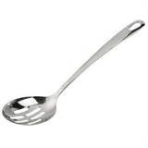  Serving spoon | 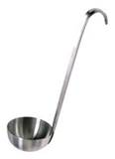  Soup ladle  Soup ladle
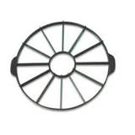  Cake portion guide | 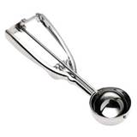  Ice cream scoop  Ice cream scoop
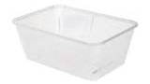  Plastic tubs | 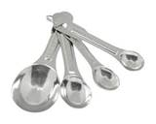  Measuring spoons
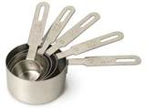  Measuring cups | 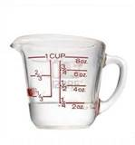  Measuring jugs

2.2 Provide sufficient and appropriate service equipment and service platforms

Introduction
Service equipment and service platforms are items that are used in the plating, decorating and display of food items.
When setting up a kitchen section it is important to have all service equipment available and at hand. This includes equipment for lifting, pouring, portioning and general handling.
For food safety reasons, food handler’s gloves must be worn if hands are to be used to effectively position food items on a service platform.

Service equipment
Service equipment should be:
- In good condition
- Clean and sanitised
- Free of chips or cracks
- Food grade standard.
Examples of service equipment
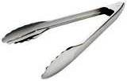  Tongs | 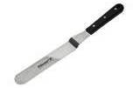  Palette knife
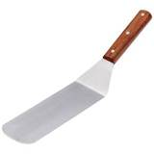  Kitchen spatula |   Ladle
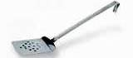  Egg slide | 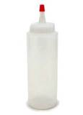  Squeeze bottle
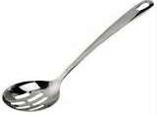  Serving spoon handlers gloves knife and fork bottle | 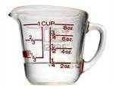  Jug
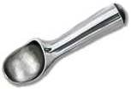  Scoop board knife and fork bottle | 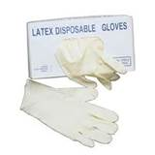  Food handlers gloves
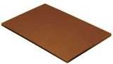  Cutting board knife and fork bottle | 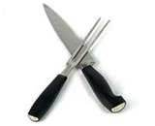  Carving knife and fork bottle

Service platforms
Service platforms are items used as a base for food presentation. These include items for individual plating and larger items for displaying food on buffets.
Service platforms should be in a clean and sanitary condition, free of cracks, scratches and chipping and must be ‘food grade’. Food grade means that the service platform will not contaminate or discolour the food items being plated or presented.

Serving plates and bowls
Traditionally, these types of serviceware are round or oval in shape. Modern trends now see more innovative items in a variety of shapes being used. This makes the overall presentation of food more visually interesting.
Many plates used in modern dining include rectangle, triangle, staggered and off centre shapes and styles.
Commonly, serviceware is ceramic; however some innovative chefs use items such as slate and highly polished wood to add a different dimension to food presentation.
The traditional colour for plates and bowls is white. This neutral colour forms a clean base to allow the natural colours of the food presented to stand out.

Depending on the food being presented, other base colours such as black or red are sometimes used.
Colours or designs that are ‘busy’ or have intricate design patterns are not recommended as they will usually detract from the food being presented.
Examples of plates and bowls
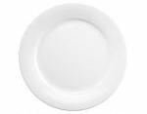  Entrée plate  Main course plate fork bottle |  |   Side plate
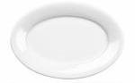  Oval plate | 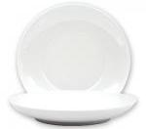  Deep plate | 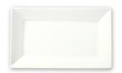  Rectangular plate
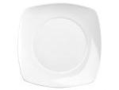  Rounded square plate  Square plate | 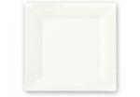 |   Triangular plate
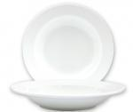  Soup/pasta bowl | 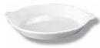  Gratin dish | 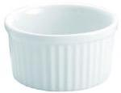  Ramekin/soufflé dish
  Glass cake plate | 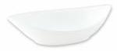  Oval point bowl | 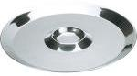  Oyster plate

Innovative service platforms
These are used by chefs who are seeking something different in the way that their food is presented. Some are altogether new and inventive; others are sometimes a new ‘twist’ on the culture or tradition of different cuisines.
If looking for a new or innovative way to present food, you must consider:
- If the item is practical – may be too thick, too heavy
- If the item is hygienic and food safe
- If the item is non-porous – can hold water/moisture.
  Slate tile | 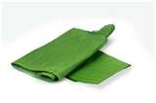  Banana leaf | 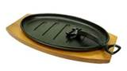  Sizzle plate

Display service platforms
These are items that are used for the presentation of food on a larger scale, such as for buffets.
Many of these items are used to add height and depth to a buffet layout.
Polished silver or stainless steel adds elegance to the overall presentation of a buffet.

Platters and stands
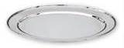  Oval platter | 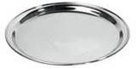  Round salver | 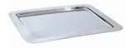  Rectangular platter
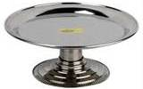  Cake stand | 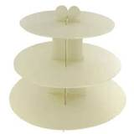  3 tier stand | 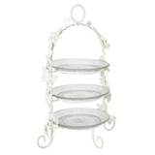  Decorative tier stand

Props
These are items that compliment food displays and can enhance a particular theme. They may also add a different dimension to the layout of a buffet, creating an interesting visual display.
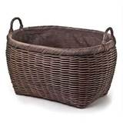  Woven basket | 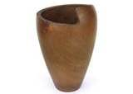  3 tier stand | 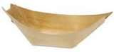  Wooden boat
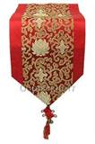  Table  runners | 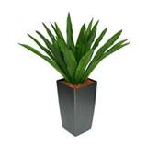  Artificial  plants | 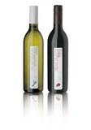  Wine  bottles

Food display units
As described previously, units for holding hot and cold foods are also considered to be service platforms.
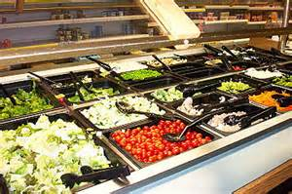
These include:
- Bains-marie
- Chafing dishes
- Salad bars
- Cake display units.
These units should be in good condition, free of scratches or dents, clean and polished.
Cold units should operate at +5°C or below and hot units at +65°C or above.
Foods displayed under these conditions should be held for a minimal amount of time and, discarded after service, especially if the items were self-serve as there is little control over cross contamination by customers.

2.3 Plate and display food items to menu style

Introduction
Different service styles and the type and quality standards of the food business will usually reflect in how menu items are presented to the customer.
Service styles directly relate to how the customer expects to dine. Generally, customers will consider the following when choosing how they themselves or their invited guests dine:
- Time of day
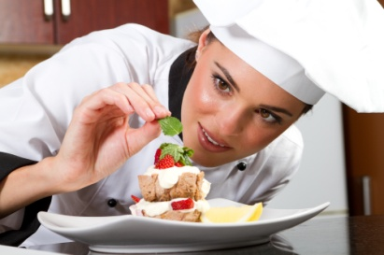
- Occasion
- Service period (breakfast, lunch, dinner, supper)
- Number of courses
- Time constraints
- Number of guests dining together
- Desired cuisine style.

Menu styles

À la carte
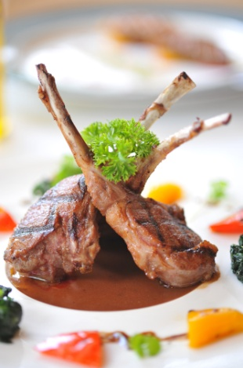
A la carte service involves customers ordering dishes from an extensive menu. This style of service allows food to be cooked to order, usually for small groups of customers arriving and dining at different times.
Courses on an à la carte menu include; appetiser, entrée, main course and dessert.
Each kitchen section will prepare and cook different elements of the menu and will have different set up requirements in relation to food, equipment and serviceware.
A la carte food presentation is usually the most detailed in presentation and menu items may have many elements.
Menu components are generally of high quality and many, such as vegetables, starches and garnishes are par cooked to assist with faster cooking and service.
Completed meals and their components are sent to the ‘pass’ where the senior Chef will quality check and may add final touches such as sauces and garnishes to the dishes before sending them out to the diners.
Meals that do not meet the standards of the business are often discarded and the meal must be produced again. In some instances, a meal may be replated if the problem is simply a matter of poor presentation.

Banqueting
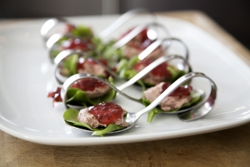
In banqueting, customers have a limited menu choice. This style of service is usually delivered for large functions, such as weddings and birthday parties, where the guests are usually seated and served at the same time.
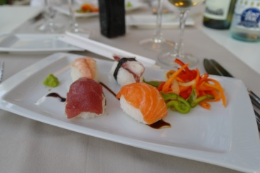
It would not be possible to service so many customers choosing from an extensive à la carte menu when they are to be dining together, therefore choices are limited.
There are normally only 3 or 4 courses served on a banquet menu: appetiser, entrée, main course and dessert. There are usually only 2 menu choices for each course.
Service set up for banqueting usually involves menu components being precooked (hot meals) trayed up, re-thermalised and stored in heated units sometimes referred to as ‘hot boxes’.
Service staff form a ‘line’ and each person is responsible for placing one or two food components on the plate as it is passed along a plating table. This repetitive style of plating usually ensures consistency of plating and presentation.
A senior Chef will usually service the end of the line for final inspection, quality control and cleaning drips or spills.
Meals not meeting the required uniform standard of presentation are rejected.

Buffet
Buffet service entails the layout and display of hot and cold food items. Generally customers may serve themselves from a wide variety of displayed menu items.
In some instances, foods may be portioned and plated by service staff, such as at a carving station for roast meats or at a bain-marie. This assists with portion control and observation of food hygiene procedures.
Sections of the buffet may include appetisers, entrees, soups, wet and dry main courses, carved roast meats, sauces, vegetables, rice and pasta dishes, salads and desserts.
Aside from decorating and garnishing individual food items, a buffet layout may also be decorated with other items to enhance the overall presentation and create a ‘spectacle’ for the customers.
Buffet centrepieces can include:
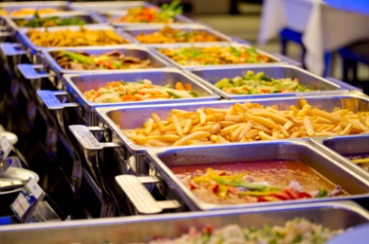
- Flower arrangements
- Decorated centrepieces
- Ice carving
- Margarine models
- Chocolate and marzipan models
- Themed furnishings and props
- Themed ingredients or items
- Carved fruits and vegetables
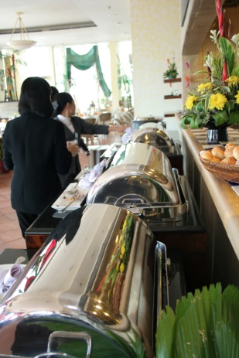
- Fruit and vegetable baskets
- Props such as vases and artificial plants.
A buffet may be prepared for any service period at the request of the customer or client. This can include breakfast, lunch, dinner and supper.
Large hotels usually serve a buffet breakfast as this frees the kitchen for preparation of menu items for an à la carte lunch and dinner service.
Food for buffets is usually placed neatly into trays or onto plates and platters then garnished.
Hot items may be kept in a bain-marie or chafing dishes and cold items in a salad well, open display chiller or on ice.
During buffet service, staff should ensure that emptied or unattractive food containers are removed and these are replaced with fresh items.
It is also important to continually replace unclean service utensils such as tongs, spoons and ladles with clean ones.

2.4 Present food neatly and attractively

Introduction
When plating food, care and attention must be paid to ensure the meals are plated:
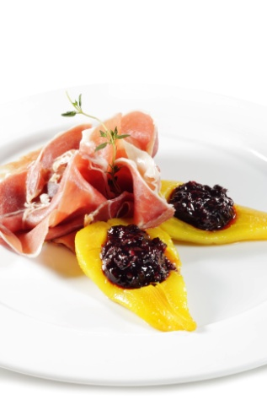
- Neatly and attractively
- Without spills or drips
- To enterprise quality, and other standards in keeping with the requirements for the specific dish
- Taking into consideration:
- Eye appeal
- Colour and contrast
- Temperature of food and service style and equipment
- Classical and innovative arrangement styles.
Poor presentation standards and practices can ruin hours of work and lots of effort.
It can greatly reduce customer enjoyment of the meal, and lower the appreciation of the dining experience and the overall impression of the business.
Poor food presentation can adversely affect repeat and referral business.
You must always consider that customers eat with their eyes. They see the food before they eat it and this stimulates the appetite.
The way in which we plate and present food must entice, inspire and tempt customers.

Neat and attractive plating
All dishes must be served neatly and attractively.
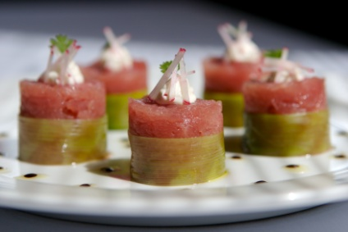

During a service period, the Head or Sous Chef will usually check that this occurs for each and every dish before it leaves the kitchen.
Plating considerations include:
- All dishes of the same type must look identical in terms of serve size, number of items, layout of the dish components, where the garnish is placed, where the sauce has been served
- Photographs of model dishes or menu cards, must be observed
- The correct sized plate/dish must be used to compliment the meal
- The same service plate/dish must be used for all the same menu items
- Balance must be achieved:
- This is the overall impression created by the look of the meal. There may, indeed, be some focal visual point to the dish. Some dishes have their appearance on the plate planned with as much care and thought as went into creating the recipe for the item
- It takes into account the precise placement of different shaped and sized items on the plate to create a balanced appearance rather than an unequal or uneven impression
- It also means balancing food textures rather than having a dominance of one texture to the absence of any other
- It means not overdoing a certain element of the presentation – often the garnish is overdone
- A final visual inspection of the meal must be made before it is released from the kitchen.

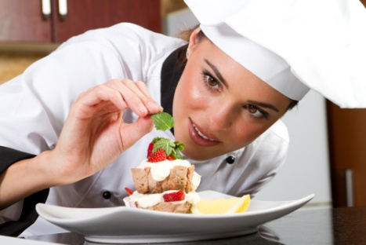
Spills or drips
The final touches to a dish before it leaves the kitchen must be to remove:
- Any sign of drips or spills, spots, or run marks
- Any smudges caused by removing drips or spills
- Any finger marks that may be the plate.
This consideration may also extend to inspecting the precision with which sauces may have been added and rejecting or re-doing any plates not meeting the required presentation standard.

Quality and other presentation standards
A food business must first have standards set in place and these standards must be communicated to the staff.
Training and briefing sessions and the use of colour photographs are the most common methods of demonstrating the required business standards.
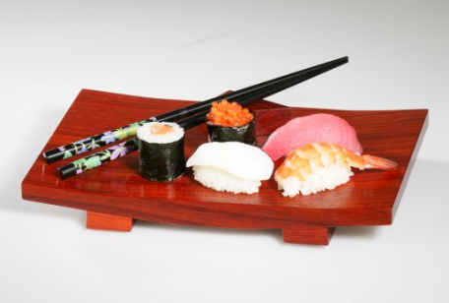
These standards may include:
- Where foods are placed upon the plate
- Where garnishes are added or placed
- Making sure dishes are plated within designated timeframes
- Ensuring the correct temperature of plates and other serviceware
- Ensuring special customer requests are being met Eye appeal.
All of the previously described points relate to the final eye appeal of the dish. The design and layout of a dish can be a very memorable part of the meal.
Eye appeal, however, needs to be kept in context. In many food establishments the need for good, wholesome food served quickly and priced competitively will outstrip the demand for excellence in visual appearance.
In these situations there may be the need for compromises on the basis of cost, speed of service and the identified preferences of customers.

Colour and contrast

Consideration of colours must be factored into the presentation of any dish or menu item. Food colours must always be balanced and harmonised. It is important that the plate is arranged so that similar colours do not come together as this can make the meal look dull and unattractive.
Using a coloured diagram or photograph of the menu item will help you to guide the positioning of different coloured foods.
A colourful garnish can lift the presentation of a meal but care must be taken not to over garnish or allow the garnish to overwhelm the main components of the dish.

Height and depth
Giving food height increases the overall presentation and can give the impression that the portion is a little larger than it actually is. Height can be achieved by stacking food, placement on top of other food items of using a tall garnish, such as a tuille biscuit.
Care must be taken as the food item may ‘topple’ over as it is being carried to the table. In some instances, whilst height may make some foods look more appealing, it may have an adverse effect insofar as it may be difficult to eat. An example of this may be an overly filled sandwich or burger.
Depth can be given to a dish simply by using clever placement of components of a menu item.
Placing the taller component to the rear of the plate and having other components ‘tapering’ down toward the front can give the impression of depth, adding an interesting characteristic to the dish.
The same principle is usually applied to buffet service where certain items are placed at different heights and levels on the buffet table. Sometimes, ‘props’ such as tall vases are used to give depth to the presentation of buffet items.

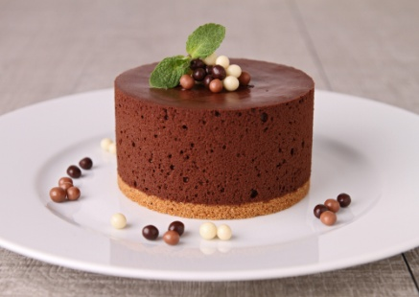
Temperature of food and equipment
The required service temperature of meals is a common priority in kitchens in relation to food service.
Cold (and especially frozen) dishes demand first priority so they arrive at table in the appropriate state. Quite simply, hot food must be served hot, and cold food must be served cold.
This means the first priority is often cold food. The kitchen is generally a hot place, so cold food which has been removed from refrigeration will quickly gain heat and rapidly reach ‘room temperature’ which in a kitchen can be up to +40°C.
Speed is essential when plating cold and frozen meals. The same speed is usually not required when plating hot food because it is often heated above eating temperature and will withstand some delay in plating.
Plates should be of an appropriate temperature; chilled for salads, cold entrees and desserts and warmed for hot dishes.

Classical and cultural considerations
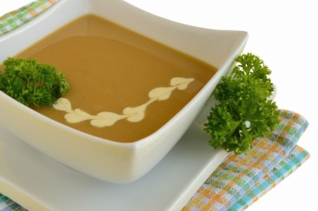
Classical menu items are dishes that were created many years ago and are standard to most chefs’ training. Many are of European origin.
These dishes were usually developed around a theme and named after certain people, places or techniques used in the preparation and service of the item.
The presentation of these items in the modern day is open to interpretation by many chefs; however the fundamental rules should apply.
If a classical dish is served with particular condiments and garnishes or has a specific texture or ingredient this must not change.
Where a customer orders a classical dish, the expectation must be met in taste, texture, components and presentation.
A prawn cocktail may be plated in different ways, however the standard components; lettuce chiffonnade, shelled prawns, cocktail sauce and lemon wedge should always be present.
Cultural considerations in food presentation may relate to:
- Specific ingredients
- Garnishes
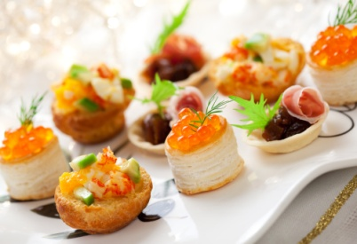
- Standard accompaniments
- Method of cookery
- Food texture
- Sequence of service
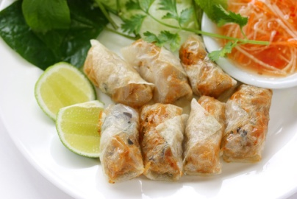
- Ceremony
- Philosophy or religion
- Dietary requirements.
For example, there is an expectation in many Asian cultures that rice will be served at a meal and is, in fact, the integral part of the meal. In most Western or European cultures, rice would either be the main component (risotto, paella) or served as a side dish or accompaniment.

Work Projects
It is a requirement of this Unit you complete Work Projects as advised by your Trainer. You must submit documentation, suitable evidence or other relevant proof of completion of the project to your Trainer by the agreed date.
2.1 Speak to a senior kitchen member about portion control in your workplace. Write down the standard portion sizes for soup, entrée, main course component, vegetables and accompaniments.
Present this to your trainer/assessor.
2.2. Observe service periods in your workplace. Make a list of all service equipment used in plating and portioning menu items.
Present this list to your trainer.
2.3. Write down what service styles are used in your workplace and what service periods are offered to its customers.
Present this to your trainer/assessor.
2.4. Observe service periods in your workplace and write down any procedures used for controlling the quality of food presentation before it is sent to the customer.
Obtain menu cards or photographs of 3 menu items from your menu. Describe the presentation and garnishing of each item.
Present this information to your trainer/assessor.

Summary

Plate and present foods
Portioning
Portioning and portion control are important aspects of food presentation
Food presented to customers must be consistent in quantity and size and uniform in shape and appearance
Portions sizes or quantities should always be in line with business policy or standard recipes
Portioning refers to the amount of food allocated to a particular menu item. This may include several components to a dish or a single serve item
Good portion control practices allow the kitchen to control its costs
All dishes of the same type must look the same. The position of the food components should be the same on all plates.
Service equipment
Service equipment and service platforms are items that are used in the plating, decorating and display of food items
Service equipment should be in good condition, clean and sanitised, free of chips or cracks and of a food grade standard
Service platforms are items used as a base for food presentation. These include items for individual plating and larger items for displaying food on buffets
Service platforms should be in a clean and sanitary condition, free of cracks, scratches and chipping and must be ‘food grade’
Colours or designs that are ‘busy’ or have intricate design patterns are not recommended as they will usually detract from the food being presented.
Service styles
Different service styles and the type and quality standards of the food business will usually reflect in how menu items are presented to the customer
Service styles directly relate to how the customer expects to dine
A la carte service involves customers ordering dishes from an extensive menu. This style of service allows food to be cooked to order, usually for small groups of customers arriving and dining at different times
Banqueting menus usually have a limited choice. This style of service is usually delivered for large functions, such as weddings and birthday parties, where the guests are usually seated and served at the same time
Buffet service entails the layout and display of hot and cold food items. Generally customers may serve themselves from a wide variety of displayed menu items.
Plating and presenting food
When plating food, care and attention must be paid to ensure the meals are plated neatly and attractively, without spills or drips and to the quality standards of the business
Plating considerations include:
Eye appeal
Colour and contrast
Temperature of food and service style and equipment
Classical and innovative arrangement styles
Height and depth
All dishes must be served neatly and attractively
During a service period, the Head or Sous Chef will usually quality check each and every dish before it leaves the kitchen
If a classical dish is served with particular condiments and garnishes or has a specific texture or ingredient this must not change
Where a customer orders a classical dish, the expectation must be met in taste, texture, components and presentation
Cultural considerations in food presentation may relate to:
Specific ingredients
Garnishes
Standard accompaniments
Method of cookery
Food texture
Sequence of service
Ceremony
Philosophy or religion
Dietary requirements.

Element 3:
Store garnishes and accompaniments

3.1 Store items correctly

Introduction
Correct storage of food items relates directly to quality and food safety.
Prepared foods must be stored in an appropriate vessel and at the correct temperature to ensure that it is not exposed to cross-contamination or bacterial growth.
Other factors that can affect food quality include strong odours from other foods and elements that may affect appearance such as humidity, excess heat, air contact and natural enzymes in some fruits and vegetables.


Cool room temperature
The cool room is the most common storage area for prepared foods, although some food items will suffer a loss in quality, especially in texture, if stored under refrigeration.
Cool room temperature must be +5° Celsius (+41°F) or below in order to minimise bacterial growth, especially in protein foods such as meat, seafood, dairy and cooked starches such as rice.

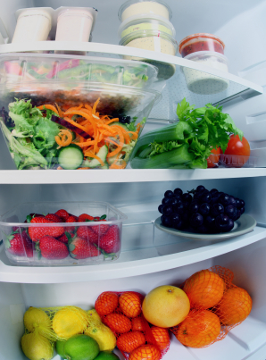
Cool room placement
All prepared foods including garnishes, condiments and accompaniments should be well covered or wrapped. The most common and best medium for this is plastic cling wrap as it not only minimises cross-contamination but does not allow circulating air to ‘dry out’ food items.
Plastic cling wrap can also create a barrier to strong odours from other foods that may be absorbed, especially in the case of dairy products.
Ideally, prepared food should be stored in a separate coolroom from raw foods; however in many kitchens this is not practical.
As a standard rule, prepared food should always be stored above raw foods and away from strong smelling foods such as raw seafood or blue mould cheeses.

Time in cool storage
Prepared foods can usually be kept in cool storage for a period of time; however protein foods will still suffer slow bacterial growth.
Ideally, prepared foods should be stored for no longer than 24 hours before using or discarding.
Excessive storage time will affect the quality of prepared food items. Some examples of this include:
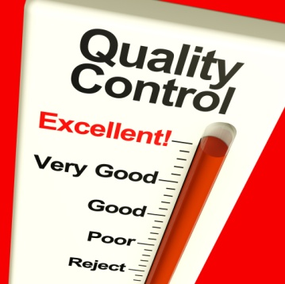
- Crumbed/breaded foods will absorb moisture and become ‘soggy’
- Dairy foods such as whipped cream may absorb food odours
- Sauces and custards can split or weep
- Leafy garnishes can lose moisture and wither
- Chopped fresh herbs can compost
- Fruits and fruit juices can ferment.

Time in freezer
Ideal freezing temperatures are between -15°C to -18°C, depending on the type of food being stored.
Although freezing foods will stop the growth of bacteria, food quality can be affected by an excessive freezing period.
Prepared foods that are quickly frozen (within 2 hours) will lose less quality than foods that are slowly frozen.
Most prepared foods will freeze well for 2-3 months before beginning to suffer a loss in quality.
Defrosting should be done gradually and under refrigerated conditions. This is so the food does not lose too much moisture which would ruin the taste and presentation.
To repeat foods must be well wrapped. Plastic cling wrap is best as it contacts all surfaces of the food. Poorly wrapped food when exposed to circulating air at -18°C will suffer ‘freezer burn’. This is where the food will dry out leaving an unpleasant appearance and poor texture when cooked.

Other storage processes
Vacuum packaging
A storage practice that has become more common in kitchens is the use of vacuum packaging equipment.
This process removes all air from the packaged product, which can increase its storage time whether chilled or frozen. Zero air contact allows food to remain fresh for longer periods.
Vacuum packaging is also a good method of portion controlling.
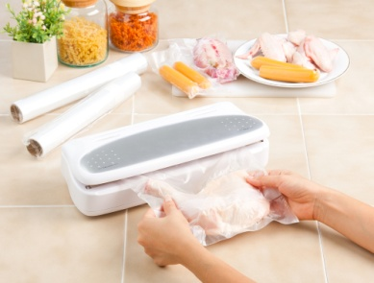
Some foods that can be packaged this way include:
- Individual meat, fish, poultry portions
- Soups, sauces and stews
- Fruit or vegetable purees.

Storage on ice
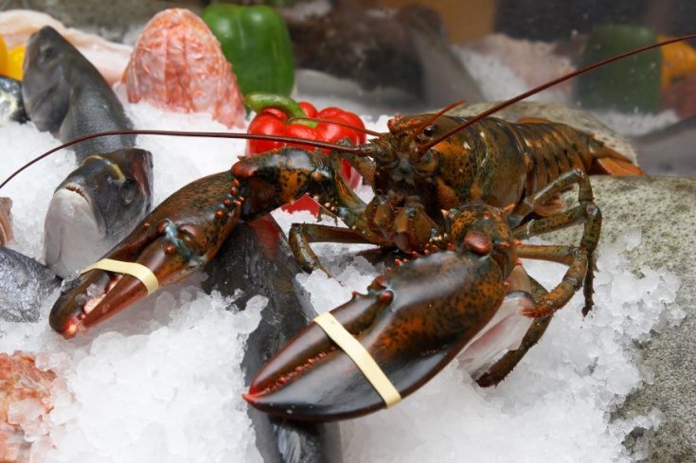
The use of ice as a storage medium is commonly employed for fish and shellfish.
These foods can deteriorate rapidly, even under normal refrigeration conditions (+5°C). Storing in ice can bring the temperature down to between +1°C and +3°C. This temperature range will allow for longer storage.
In addition, the moisture created by surrounding ice will help to stop the food item from drying out.
If storing food on ice, it should be placed in a perforated container to allow water from melted ice to run off.
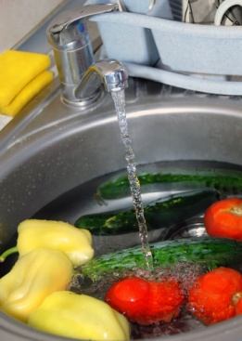
Storage in water
Leafy vegetables and herbs can lose moisture during refrigerated storage, leaving them withered and limp which makes them unpresentable.
Placing these items into very cold water for a brief period will allow them to absorb water back into the cells (osmosis) making them crisp and fresh looking.
Other food items that can be stored in water without losing flavour or quality include peeled and hard root vegetables.
Cut white fleshed fruits such as apples and pears will lose flavour and sweetness if placed in water so should be stored in stock syrup which is a boiled then cooled sugar/water mixture.
Cartouche
A cartouche is used in the storage of stocks, soups and sauces. Greaseproof or silicon paper or plastic cling wrap is used and placed in direct contact with the top of the liquid creating a barrier to air.
This stops a skin from forming which could create unattractive lumps if cooked back into the sauce or soup.

3.2 Store products appropriately in correct containers

Introduction
When considering how food items are to be stored it is important to consider the type of container or packaging medium that is to be used.
Many containers may not be suitable and may, in fact, have an adverse effect on the quality and appearance of the food items being stored.

Storage containers
Containers, packaging and wrapping materials must be suitable and appropriate to the food item to be stored.
Considerations should include:
- Size of the container – will the food fit comfortably without being forced in?
- Shape of containers – will the food lose its shape?
- Condition – is the container cracked, broken or chipped?
- Hygiene – is the container clean and sanitised?
- Food grade – is the container of a ‘food grade’ standard?
- Flat, shallow or deep - does the food require air circulation or rapid cooling?
- Later use – is the food to be cooked or heated in the container?
Examples of food grade storage vessels:
  Plastic disposable | 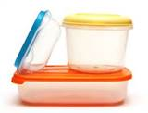  Tupperware | 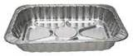  Aluminium foil
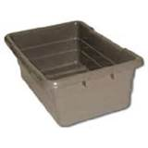  Plastic meat tub | 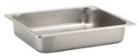  Gastronorm | 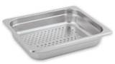  Gastronorm perforated
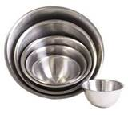  Stainless steel bowls | 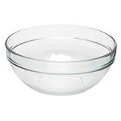  Glass bowl | 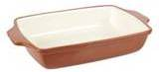  Ceramic dish
Points on storage containers:
- Stainless steel and hard plastics are most commonly used as food storage vessels. This is because they are sturdy, easy to keep clean and are non-porous
- Glass and ceramic bowls and containers may be used; however they are prone to chipping, cracks and breakage
- Cardboard boxes and cartons are not recommended for storage in coolrooms as they can harbour insects and are prone to rotting and mould
- Cast aluminium vessels can react with some foods causing them to discolour, especially white sauces and egg based items. Aluminium foil products do not have the same effect
- Decanted chemical containers should definitely not be used for food storage as they may still contain traces of poisonous substances
- Storage containers must be clean and sanitised before and after assembly and use.

Packaging and wrapping materials
Other items used for storage include materials for covering food if an appropriate lid or storage vessel is unavailable:
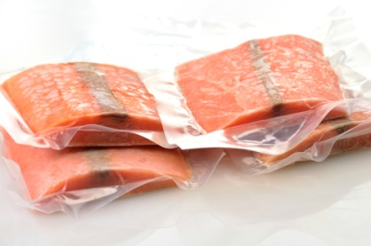
- Plastic cling film/wrap
- Aluminium foil
- Silicon paper
- Greaseproof paper
- Plastic Cryovac bags
- Freezer bags
- Zip lock plastic bags.
All of these items are made from food grade materials.

3.3 Label products correctly

Introduction
Labelling plays an important part in food storage. Not only does the quality of food needed to be monitored but also food safety requirements.
These requirements are a standard in many countries and are an integral support program for food safety systems.
Many large establishments, particularly where banqueting is used, will label and freeze small batches of prepared foods for a period of time. This is usually kept as evidence should customers report becoming ill from consuming food prepared at the establishment.
Labelling also ensures that the correct and appropriate food item is easily identified and selected for use.

Labelling prepared menu items, garnishes, accompaniments
All prepared foods should be clearly labelled prior to storage.
Information should include:
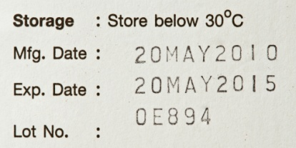
- Name of the item
- Date the item was first stored
- Time that item was first stored
- Temperature – if being process tested
- Type of storage – chilled, frozen, thawing.
Writing must be legible and the label must be somehow fixed to the container.
Many companies produce specialised labels for food storage, one of the most common is ‘day dots’, a colour coded labelling system which states the day of the week. The date is written in by kitchen staff.
Some labels are simple and only state the day and date while others have sections where other important information, such as in the above points, can be included.
The information provided on food storage labels will assist staff in making a decision as to whether the food is fresh, of a quality standard or if it is safe to use.

3.4 Store items in correct conditions to maintain freshness and quality

Introduction
Conditions for storage of prepared food items will depend upon the type of food and how long it will be stored.

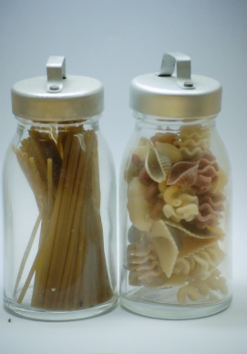
Correct conditions

Temperature and humidity
Humidity levels can affect food items in storage.
Excess moisture in the air can be absorbed by crisp items such as biscuits, meringues, crackers and potato crisps.
This can lead to the item becoming soggy and even collapsing, which can lead to poor presentation, especially if the item is a garnish designed to give height to a dish.
Dry, crisp food items should be stored in a cool dry area with little humidity.

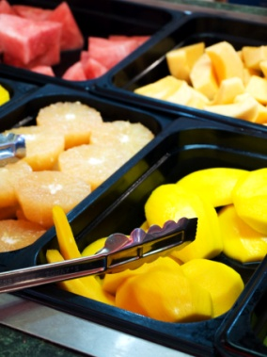
Exposure to air
Some food items will lose moisture due to air exposure and low humidity. This is commonly referred to as ‘staling’.
Foods affected by staling through exposure include baked goods such as breads, cakes, pastries and biscuits.
By storing in an airtight container, staling will be drastically slowed.
White flesh fruits such as apples and pears, when peeled or cut begin to turn brown. This is due to enzymes in the fruit reacting with oxygen.
Coating or rubbing with an acid such as lemon juice will slow this process down, however the taste of the fruit will be compromised.
Storing in fresh water is not an option as the fruit will lose its flavour and sweetness through osmosis. These fruits should be stored in a sugar/water solution known as ‘stock syrup’ to minimise the osmosis process.
Protein foods such as meat, chicken and fish can dry out if not effectively covered or wrapped. This can lead to an unattractive appearance when the food is cooked and presented.


Refrigerated storage
This requires foods to be subject to low humidity and a temperature of between +1°C to +5° C, depending on the food type.
Refrigerated foods will continue to deteriorate in quality and freshness over a period of time.
As mentioned previously in this section, all prepared foods requiring refrigeration must be tightly wrapped or covered, labelled and dated. Stock rotation principles must also be observed.

Frozen storage
This requires foods to be subject to low humidity and temperatures between -15°C to -18°C in a solid state.
Ideally dairy foods, such as ice cream, should be as cold as possible (-18°C) as it will remain firm during periods when it is exposed to kitchen temperatures during service.
When storing foods under frozen conditions it should be packaged in small batches to allow rapid freezing to take place. Slow freezing allows large ice crystals to build up which breaks down cells in food, leading to excessive loss of moisture during thawing.
This leads to thawed foods having a dry appearance and texture when cooked.

Dry storage
This requires foods to be stored in a relatively cool area with very low humidity at between +18°C to +24°C. This is sometimes referred to as ‘ambient’ or ‘room’ temperature.
Most food should be wrapped. However, this can have an adverse effect on some foods leading to sogginess if the area is too humid.
Foods should be stored in clean food grade containers that are pest proof.
Long term dry storage of any food will lead to staling, regardless of how it is stored.

Stock rotation
Date labels also assist in correct stock rotation as items are clearly identified.
When storing fresh batches of prepared foods, older items should always be brought to the front and the fresher batch placed to the rear.
This procedure is commonly referred to as FIFO which stands for First In, First Out.
The FIFO procedure helps to ensure that the older prepared food is utilised first, leading to:
- Quality control of food items
- Freshness of food being maintained as it is not left in storage for long periods of time
- Meeting food safety requirements.

Reporting faults
Faults in food storage can not only adversely affect quality but can lead to food borne illness, especially when storing potentially hazardous foods such as meats, seafood, dairy food and cooked starches such as rice.
Faults must be reported to a supervisor for immediate action in line with the business policy and procedure.
Faults during storage may include:
- Incorrect temperatures
- Faulty equipment
- Unwrapped or poorly wrapped items
- Unclean storage containers
- Inappropriate storage vessels
- Unlabelled food items
- Food items past expiry date.
Generally, a properly implemented food safety program will minimise problems with food storage.
The food safety program contains record sheets for documenting storage activities and temperatures of food and equipment.
The food safety program will also outline any corrective measures that should be taken if faults are found with storage equipment, practices and procedures.
Recommended storage of garnish items
Garnish | Storage requirements
Picked herbs  Salad leaves  Edible flowers  Shoots | In water and refrigerated – short term only  Iced water will help to crisp up herbs and leaf vegetables quickly
Chopped herbs | Rinsed and dried. Airtight container and refrigerated – short term only
Cut vegetables  Cooked vegetables | Root and stalk vegetables - In water and refrigerated  Fruit type vegetables - Airtight container and refrigerated  Airtight container and refrigerated – short term only
Cut fruits | Airtight container and refrigerated
Cut white flesh fruits | Coat with lemon juice to stop enzyme activity – ‘browning’ or store in a sweet stock syrup
Biscuits, pastry and croutons | Airtight container in dry storage area with low humidity
Seeds and nuts | Airtight container in dry storage area
Eggs, crepes | Airtight container and refrigerated – short term only
Sugar based garnishes  Meringues, candy and toffee | Airtight container in dry storage area– short term only
Recommended storage of accompaniments:
Accompaniment | Storage requirements
Salsa, sambals, pastes | Refrigerate, covered or in bottles or jars
Prepared sauces and condiments | Refrigerate, covered or in bottles or jars
Prepared sauces and condiments – egg or dairy based | Refrigerate, covered or in bottles or jars
Dried chillies, nuts, fried shallots and herbs, bread croutons | Well wrapped or covered in cool dry area
Dairy foods – cream, cheese, yoghurt | Refrigerate, well covered and away from strong smelling foods
Breads, rotis,naan | Well wrapped or covered in cool dry area
Cut fruits or vegetables | Refrigerate, well covered. Do not store cut fruits in water as they will lose their flavour
As many accompaniments are quite strong in odour, it is recommended that you store these items away from dairy foods as these can easily absorb strong smells.

Work Projects
It is a requirement of this Unit that you complete Work Projects as advised by your Trainer. You must submit documentation, suitable evidence or other relevant proof of completion of the project to your Trainer by the agreed date.
3.1 Review section 3.1 of this Workbook, then consider your workplace storage practices. Write down all of the storage practices that are used. Present this to your trainer/assessor.
3.2. Create a list of all storage containers and wrapping materials used in your workplace. Present this list to your trainer/assessor.
3.3. Locate any items used in your workplace for labelling food items. Give samples of these to your trainer/assessor.
3.4. Inspect the storage areas in your work place. Make a list of garnishes and food accompaniments in each storage area. Include details on how each item is stored to maintain its quality and freshness.

Summary

Store garnishes and accompaniments
Prepared foods must be stored in an appropriate vessel and at the correct temperature to ensure that it is not exposed to cross contamination or bacterial growth
Factors that can affect food quality during storage include strong odours from other foods, humidity, excess heat, air
Prepared foods including garnishes, condiments and accompaniments should be well covered or wrapped
Prepared food should always be stored above raw foods and away from strong smelling foods
Ideally, prepared foods should be stored for no longer than 24 hours before using or discarding
Excessive storage time will affect the quality of prepared food items
Refrigerated foods should be subject to low humidity and a temperature of between +1°C to +5° C, depending on the food type
Ideal freezing temperatures are between - 15°C to -18°C, depending on the type of food being stored
Dry food storage requires foods to be stored in a relatively cool area with very low humidity at between +18°C to +24°C
Although freezing foods will stop the growth of bacteria, food quality can be affected by an excessive freezing period
When considering how food items are to be stored it is important to consider the type of container or packaging medium that is to be used
Containers, packaging and wrapping materials must be suitable and appropriate to the food item to be stored
Stainless steel and hard plastics are most commonly used as food storage vessels. This is because they are sturdy, easy to keep clean and are non-porous
Other items used for storage and wrapping of food include plastic cling film/wrap, aluminium foil and silicon paper
All prepared foods should be clearly labelled and dated prior to storage
Conditions for storage of prepared food items will depend upon the type of food and how long it will be stored
Humidity levels can affect food items in storage as excess moisture in the air can be absorbed by crisp items such as biscuits
Some food items such as baked goods will become ‘stale’ due to air exposure and low humidity if incorrectly wrapped or stored
Faults during storage may include incorrect temperatures, faulty equipment, unwrapped items and unclean storage containers
Faults in food storage must be reported to a supervisor for immediate action in line with the business policy and procedure.

Presentation of written work

1. Introduction
It is important for students to present carefully prepared written work. Written presentation in industry must be professional in appearance and accurate in content. If students develop good writing skills whilst studying, they are able to easily transfer those skills to the workplace.

2. Style

Students should write in a style that is simple and concise. Short sentences and paragraphs are easier to read and understand. It helps to write a plan and at least one draft of the written work so that the final product will be well organized. The points presented will then follow a logical sequence and be relevant. Students should frequently refer to the question asked, to keep ‘on track’. Teachers recognize and are critical of work that does not answer the question, or is ‘padded’ with irrelevant material. In summary, remember to:
- Plan ahead
- Be clear and concise
- Answer the question
- Proofread the final draft.

3. Presenting Written Work
Types of written work
Students may be asked to write:
- Short and long reports
- Essays
- Records of interviews
- Questionnaires
- Business letters
- Resumes.
Format
All written work should be presented on A4 paper, single-sided with a left-hand margin. If work is word-processed, one-and-a-half or double spacing should be used. Handwritten work must be legible and should also be well spaced to allow for ease of reading. New paragraphs should not be indented but should be separated by a space. Pages must be numbered. If headings are also to be numbered, students should use a logical and sequential system of numbering.
Cover Sheet
All written work should be submitted with a cover sheet stapled to the front that contains:
- The student’s name and student number
- The name of the class/unit
- The due date of the work
- The title of the work
- The teacher’s name
- A signed declaration that the work does not involve plagiarism.
Keeping a Copy
Students must keep a copy of the written work in case it is lost. This rarely happens but it can be disastrous if a copy has not been kept.
Inclusive language
This means language that includes every section of the population. For instance, if a student were to write ‘A nurse is responsible for the patients in her care at all times’ it would be implying that all nurses are female and would be excluding male nurses.
Examples of appropriate language are shown on the right:
Mankind | Humankind
Barman/maid | Bar attendant
Host/hostess | Host
Waiter/waitress | Waiter or waiting staff

Recommended reading
Hobday.Cara; 2010; Food Presentation Secrets: Styling Techniques of Professionals; Firefly Books
Leonard.E; 2011; Modern Buffets: Blueprint for Success;Wiley
QA International; 2009; The Visual Food Lover's Guide: Includes essential information on how to buy, prepare and store over 1,000 types of food; John Wiley & Sons Inc
Styler.Christopher; 2006; Working the Plate: The Art of Food Presentation; Houghton Mifflin Harcourt
The Culinary Institute of America (CIA); 2011 (9th edition); The Professional Chef; Wiley
The Culinary Institute of America (CIA); 2014 (4th edition); Techniques of Healthy Cooking; Wiley
The Culinary Institute of America (CIA); 2012 (4th edition); Garde Manger: The Art and Craft of the Cold Kitchen; Wiley
Trotter, Charlie & Wareing; 2008; Knife skills in the kitchen; DK Publishing, New York
Underly, Kari; 2011; The Art of Beef Cutting; Wiley

Trainee evaluation sheet

Present and display food products
The following statements are about the competency you have just completed.
Please tick the appropriate box | Agree | Don’t Know | Do Not Agree | Does Not Apply
There was too much in this competency to cover without rushing.
Most of the competency seemed relevant to me.
The competency was at the right level for me.
I got enough help from my trainer.
The amount of activities was sufficient.
The competency allowed me to use my own initiative.
My training was well-organized.
My trainer had time to answer my questions.
I understood how I was going to be assessed.
I was given enough time to practice.
My trainer feedback was useful.
Enough equipment was available and it worked well.
The activities were too hard for me.

The best things about this unit were:

The worst things about this unit were:

The things you should change in this unit are:

Trainee Self-Assessment Checklist
As an indicator to your Trainer/Assessor of your readiness for assessment in this unit please complete the following and hand to your Trainer/Assessor.

Present and display food products
 |  | Yes | No*
Element 1: Prepare garnishes and accompaniments
1.1 | Identify menu items that require garnishes and/or accompaniments
1.2 | Prepare various garnish and/or accompaniments
1.3 | Set up for service
Element 2: Plate and present foods
2.1 | Portion food items to enterprise standards
2.2 | Provide sufficient and appropriate service equipment and service platforms
2.3 | Plate and display food items to menu style
2.4 | Present food neatly and attractively
Element 3: Store garnishes and accompaniments
3.1 | Store items correctly
3.2 | Store products appropriately in correct containers
3.3 | Label products correctly
3.4 | Store items in correct conditions to maintain freshness and quality

Statement by Trainee:
I believe I am ready to be assessed on the following as indicated above:
Signed: | _____________________________ | Date: | ______ / ______ / ______
Note:
For all boxes where a No* is ticked, please provide details of the extra steps or work you need to do to become ready for assessment.





